Question 1Skipped
One of the foundational technologies provided by the Databricks Lakehouse Platform is an open-source, file-based storage format that brings reliability to data lakes.

Which of the following technologies is being described in the above statement?
Delta Lives Tables (DLT)
Correct answer
Delta Lake
Apache Spark
Unity Catalog
Photon
Overall explanation
Delta Lake is an open source technology that extends Parquet data files with a file-based transaction log for ACID transactions that brings reliability to data lakes.

Reference: https://docs.databricks.com/delta/index.html

Study materials from our exam preparation course on Udemy:
- Lecture
- Hands-on

Domain
Databricks Lakehouse Platform
Question 2Skipped
Which of the following commands can a data engineer use to purge stale data files of a Delta table?

DELETE
GARBAGE COLLECTION
CLEAN
Correct answer
VACUUM
OPTIMIZE
Overall explanation
The VACUUM command deletes the unused data files older than a specified data retention period.

Reference: https://docs.databricks.com/sql/language-manual/delta-vacuum.html

Study materials from our exam preparation course on Udemy:
- Lecture
- Hands-on
Domain
Databricks Lakehouse Platform
Question 3Skipped
In Databricks Repos (Git folders), which of the following operations a data engineer can use to save local changes of a repo to its remote repository ?
Create Pull Request
Commit & Pull
Correct answer
Commit & Push
Merge & Push
Merge & Pull
Overall explanation
Commit & Push is used to save the changes on a local repo, then uploads this local repo content to the remote repository.

References:
- https://docs.databricks.com/repos/index.html
- https://github.com/git-guides/git-push

Study materials from our exam preparation course on Udemy:
- Hands-on
Domain
Databricks Lakehouse Platform
Question 4Skipped
In Delta Lake tables, which of the following is the primary format for the transaction log files?
Delta
Parquet
Correct answer
JSON
Hive-specific format
XML
Overall explanation
Delta Lake builds upon standard data formats. Delta lake table gets stored on the storage in one or more data files in Parquet format, along with transaction logs in JSON format.

Reference: https://docs.databricks.com/delta/index.html

Study materials from our exam preparation course on Udemy:
- Lecture
- Hands-on
Domain
Databricks Lakehouse Platform
Question 5Skipped
Which of the following functionalities can be performed in Databricks Repos (Git folders)?
Create pull requests
Create new remote Git repositories
Delete branches
Create CI/CD pipelines
Correct answer
Pull from a remote Git repository
Overall explanation
Databricks Repos supports git Pull operation. It is used to fetch and download content from a remote repository and immediately update the local repo to match that content.

References:
- https://docs.databricks.com/repos/index.html
- https://github.com/git-guides/git-pull

Study materials from our exam preparation course on Udemy:
- Hands-on

Domain
Databricks Lakehouse Platform
Question 6Skipped
Which of the following locations completely hosts the customer data ?
Correct answer
Customer's cloud account
Control plane
Databricks account
Databricks-managed cluster
Repos
Overall explanation
According to the Databricks Lakehouse architecture, the storage account hosting the customer data is provisioned in the data plane in the Databricks customer's cloud account.

Reference: https://docs.databricks.com/getting-started/overview.html

Study materials from our exam preparation course on Udemy:
- Lecture

Domain
Databricks Lakehouse Platform
Question 7Skipped
If ​​the default notebook language is Python, which of the following options a data engineer can use to run SQL commands in this Python Notebook ?
They need first to import the SQL library in a cell
This is not possible! They need to change the default language of the notebook to SQL
Databricks detects cells language automatically, so they can write SQL syntax in any cell
They can add %language magic command at the start of a cell to force language detection.
Correct answer
They can add %sql at the start of a cell.
Overall explanation
By default, cells use the default language of the notebook. You can override the default language in a cell by using the language magic command at the beginning of a cell. The supported magic commands are: %python, %sql, %scala, and %r.

Reference: https://docs.databricks.com/notebooks/notebooks-code.html

Study materials from our exam preparation course on Udemy:
Hands-on

Domain
Databricks Lakehouse Platform
Question 8Skipped
A junior data engineer uses the built-in Databricks Notebooks versioning for source control. A senior data engineer recommended using Databricks Repos (Git folders) instead.

Which of the following could explain why Databricks Repos is recommended instead of Databricks Notebooks versioning?
Correct answer
Databricks Repos supports creating and managing branches for development work.
Databricks Repos automatically tracks the changes and keeps the history.
Databricks Repos allows users to resolve merge conflicts
Databricks Repos allows users to restore previous versions of a notebook
All of these advantages explain why Databricks Repos is recommended instead of Notebooks versioning
Overall explanation
One advantage of Databricks Repos over the built-in Databricks Notebooks versioning is that Databricks Repos supports creating and managing branches for development work.

Reference: https://docs.databricks.com/repos/index.html

Study materials from our exam preparation course on Udemy:
- Hands-on
Domain
Databricks Lakehouse Platform
Question 9Skipped
Which of the following services provides a data warehousing experience to its users?
Correct answer
Databricks SQL
Databricks Machine Learning
Data Science and Engineering Workspace
Unity Catalog
Delta Lives Tables (DLT)
Overall explanation
Databricks SQL (DB SQL) is a data warehouse on the Databricks Lakehouse Platform that lets you run all your SQL and BI applications at scale.

Reference: https://www.databricks.com/product/databricks-sql

Study materials from our exam preparation course on Udemy:
Hands-on
Domain
Databricks Lakehouse Platform
Question 10Skipped
A data engineer noticed that there are unused data files in the directory of a Delta table. They executed the VACUUM command on this table; however, only some of those unused data files have been deleted.

Which of the following could explain why only some of the unused data files have been deleted after running the VACUUM command ?
The deleted data files were larger than the default size threshold. While the remaining files are smaller than the default size threshold and can not be deleted.
The deleted data files were smaller than the default size threshold. While the remaining files are larger than the default size threshold and can not be deleted.
Correct answer
The deleted data files were older than the default retention threshold. While the remaining files are newer than the default retention threshold and can not be deleted.
The deleted data files were newer than the default retention threshold. While the remaining files are older than the default retention threshold and can not be deleted.
More information is needed to determine the correct answer
Overall explanation
Running the VACUUM command on a Delta table deletes the unused data files older than a specified data retention period. Unused files newer than the default retention threshold are kept untouched.

Reference: https://docs.databricks.com/sql/language-manual/delta-vacuum.html

Study materials from our exam preparation course on Udemy:
- Lecture
- Hands-on
Domain
Databricks Lakehouse Platform
Question 11Skipped
The data engineering team has a Delta table called products that contains products’ details including the net price.

Which of the following code blocks will apply a 50% discount on all the products where the price is greater than 1000 and save the new price to the table?
UPDATE products SET price = price * 0.5 WHERE price >= 1000;
SELECT price * 0.5 AS new_price FROM products WHERE price > 1000;
MERGE INTO products WHERE price < 1000 WHEN MATCHED UPDATE price = price * 0.5;
Correct answer
UPDATE products SET price = price * 0.5 WHERE price > 1000;
MERGE INTO products WHERE price > 1000 WHEN MATCHED UPDATE price = price * 0.5;
Overall explanation
The UPDATE statement is used to modify the existing records in a table that match the WHERE condition. In this case, we are updating the products where the price is strictly greater than 1000.

Syntax:
- UPDATE table_name
- SET column_name = expr
- WHERE condition

Reference:
https://docs.databricks.com/sql/language-manual/delta-update.html

Domain
Databricks Lakehouse Platform
Question 12Skipped
A data engineer wants to create a relational object by pulling data from two tables. The relational object will only be used in the current session. In order to save on storage costs, the date engineer wants to avoid copying and storing physical data.

Which of the following relational objects should the data engineer create?
External table
Correct answer
Temporary view
Managed table
Global Temporary view
View
Overall explanation
In order to avoid copying and storing physical data, the data engineer must create a view object. A view in databricks is a virtual table that has no physical data. It’s just a saved SQL query against actual tables.
The view type should be Temporary view since it’s tied to a Spark session and dropped when the session ends.

Reference: https://docs.databricks.com/sql/language-manual/sql-ref-syntax-ddl-create-view.html

Study materials from our exam preparation course on Udemy:
- Lecture
- Hands-on

Domain
ELT with Spark SQL and Python
Question 13Skipped
A data engineer has a database named db_hr, and they want to know where this database was created in the underlying storage.

Which of the following commands can the data engineer use to complete this task?
DESCRIBE db_hr
DESCRIBE EXTENDED db_hr
Correct answer
DESCRIBE DATABASE db_hr
SELECT location FROM db_hr.db
There is no need for a command since all databases are created under the default hive metastore directory
Overall explanation
The DESCRIBE DATABASE or DESCRIBE SCHEMA returns the metadata of an existing database (schema). The metadata information includes the database’s name, comment, and location on the filesystem. If the optional EXTENDED option is specified, database properties are also returned.

Syntax:
DESCRIBE DATABASE [ EXTENDED ] database_name

Reference: https://docs.databricks.com/sql/language-manual/sql-ref-syntax-aux-describe-schema.html

Study materials from our exam preparation course on Udemy:
Hands-on

Domain
ELT with Spark SQL and Python
Question 14Skipped
Which of the following commands a data engineer can use to register the table orders from an existing SQLite database ?
- CREATE TABLE orders
- USING sqlite
- OPTIONS (
- url "jdbc:sqlite:/bookstore.db",
- dbtable "orders"
- )
Correct answer
- CREATE TABLE orders
- USING org.apache.spark.sql.jdbc
- OPTIONS (
- url "jdbc:sqlite:/bookstore.db",
- dbtable "orders"
- )
- CREATE TABLE orders
- USING cloudfiles
- OPTIONS (
- url "jdbc:sqlite:/bookstore.db",
- dbtable "orders"
- )
- CREATE TABLE orders
- USING EXTERNAL
- OPTIONS (
- url "jdbc:sqlite:/bookstore.db",
- dbtable "orders"
- )
- CREATE TABLE orders
- USING DATABASE
- OPTIONS (
- url "jdbc:sqlite:/bookstore.db",
- dbtable "orders"
- )
Overall explanation
Using the JDBC library, Spark SQL can extract data from any existing relational database that supports JDBC. Examples include mysql, postgres, SQLite, and more.

Reference: https://learn.microsoft.com/en-us/azure/databricks/external-data/jdbc

Study materials from our exam preparation course on Udemy:
Lecture

Domain
ELT with Spark SQL and Python
Question 15Skipped
When dropping a Delta table, which of the following explains why both the table's metadata and the data files will be deleted ?
The table is shallow cloned
The table is external
The user running the command has the necessary permissions to delete the data files
Correct answer
The table is managed
The data files are older than the default retention period
Overall explanation
Managed tables are tables whose metadata and the data are managed by Databricks.
When you run DROP TABLE on a managed table, both the metadata and the underlying data files are deleted.

Reference: https://docs.databricks.com/lakehouse/data-objects.html#what-is-a-managed-table

Study materials from our exam preparation course on Udemy:
- Lecture
- Hands-on
Domain
ELT with Spark SQL and Python
Question 16Skipped
Given the following commands:

- CREATE DATABASE db_hr;

- USE db_hr;
- CREATE TABLE employees;

In which of the following locations will the employees table be located?
dbfs:/user/hive/warehouse
Correct answer
dbfs:/user/hive/warehouse/db_hr.db
dbfs:/user/hive/warehouse/db_hr
dbfs:/user/hive/databases/db_hr.db
More information is needed to determine the correct answer
Overall explanation
Since we are creating the database here without specifying a LOCATION clause, the database will be created in the default warehouse directory under dbfs:/user/hive/warehouse. The database folder have the extension (.db)
And since we are creating the table also without specifying a LOCATION clause, the table becomes a managed table created under the database directory (in db_hr.db folder)

Reference: https://docs.databricks.com/sql/language-manual/sql-ref-syntax-ddl-create-schema.html

Study materials from our exam preparation course on Udemy:
- Lecture
- Hands-on

Domain
ELT with Spark SQL and Python
Question 17Skipped
Which of the following code blocks can a data engineer use to create a Python function to multiply two integers and return the result?
- def multiply_numbers(num1, num2):
- print(num1 * num2)
- def fun: multiply_numbers(num1, num2):
- return num1 * num2
Correct answer
- def multiply_numbers(num1, num2):
- return num1 * num2
- fun multiply_numbers(num1, num2):
- return num1 * num2
- fun def multiply_numbers(num1, num2):
- return num1 * num2
Overall explanation
In Python, a function is defined using the def keyword. Here, we used the return keyword since the question clearly asks to return the result, and not printing the output.

Syntax:
- def function_name(params):
- return params

Reference: https://www.w3schools.com/python/python_functions.asp

Domain
ELT with Spark SQL and Python
Question 18Skipped
Given the following 2 tables:
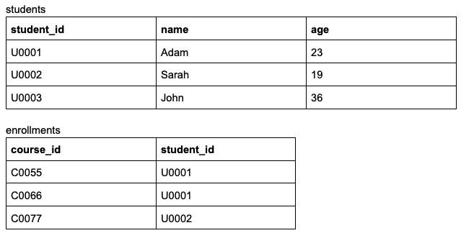

Fill in the blank to make the following query returns the below result:

- SELECT students.name, students.age, enrollments.course_id
- FROM students
- _____________ enrollments
- ON students.student_id = enrollments.student_id

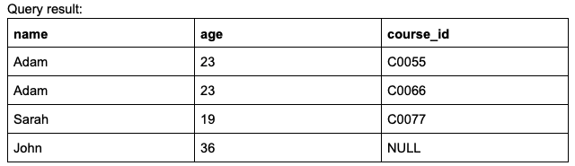
RIGHT JOIN
Correct answer
LEFT JOIN
INNER JOIN
ANTI JOIN
CROSS JOIN
Overall explanation
LEFT JOIN returns all values from the left table and the matched values from the right table, or appends NULL if there is no match. In the above example, we see NULL in the course_id of John (U0003) since he is not enrolled in any course.

Reference: https://docs.databricks.com/sql/language-manual/sql-ref-syntax-qry-select-join.html
Domain
ELT with Spark SQL and Python
Question 19Skipped
Which of the following SQL keywords can be used to rotate rows of a table by turning row values into multiple columns ?
ROTATE
TRANSFORM
Correct answer
PIVOT
GROUP BY
ZORDER BY
Overall explanation
PIVOT transforms the rows of a table by rotating unique values of a specified column list into separate columns. In other words, It converts a table from a long format to a wide format.

Reference: https://docs.databricks.com/sql/language-manual/sql-ref-syntax-qry-select-pivot.html

Study materials from our exam preparation course on Udemy:
Hands-on

Domain
ELT with Spark SQL and Python
Question 20Skipped
Fill in the below blank to get the number of courses incremented by 1 for each student in array column students.

- SELECT
- faculty_id,
- students,
- ___________ AS new_totals
- FROM faculties
TRANSFORM (students, total_courses + 1)
Correct answer
TRANSFORM (students, i -> i.total_courses + 1)
FILTER (students, total_courses + 1)
FILTER (students, i -> i.total_courses + 1)
CASE WHEN students.total_courses IS NOT NULL THEN students.total_courses + 1
ELSE NULL
END
Overall explanation
transform(input_array, lambd_function) is a higher order function that returns an output array from an input array by transforming each element in the array using a given lambda function.

Example:
SELECT transform(array(1, 2, 3), x -> x + 1);
output: [2, 3, 4]

Reference:
- https://docs.databricks.com/sql/language-manual/functions/transform.html
- https://docs.databricks.com/optimizations/higher-order-lambda-functions.html

Study materials from our exam preparation course on Udemy:
Hands-on

Domain
ELT with Spark SQL and Python
Question 21Skipped
Fill in the below blank to successfully create a table using data from CSV files located at /path/input

- CREATE TABLE my_table
- (col1 STRING, col2 STRING)
- ____________
- OPTIONS (header = "true",
- delimiter = ";")
- LOCATION = "/path/input"
FROM CSV
Correct answer
USING CSV
USING DELTA
AS
AS CSV
Overall explanation
CREATE TABLE USING allows to specify an external data source type like CSV format, and with any additional options. This creates an external table pointing to files stored in an external location.

Reference: https://docs.databricks.com/sql/language-manual/sql-ref-syntax-ddl-create-table-using.html

Study materials from our exam preparation course on Udemy:
- Lecture
- Hands-on

Domain
ELT with Spark SQL and Python
Question 22Skipped
Which of the following statements best describes the usage of CREATE SCHEMA command ?
It’s used to create a table schema (columns names and datatype)
It’s used to create a Hive catalog
It’s used to infer and store schema in “cloudFiles.schemaLocation”
Correct answer
It’s used to create a database
It’s used to merge the schema when writing data into a target table
Overall explanation
CREATE SCHEMA is an alias for CREATE DATABASE statement. While usage of SCHEMA and DATABASE is interchangeable, SCHEMA is preferred.

Reference: https://docs.databricks.com/sql/language-manual/sql-ref-syntax-ddl-create-database.html

Study materials from our exam preparation course on Udemy:
- Lecture
- Hands-on

Domain
ELT with Spark SQL and Python
Question 23Skipped
Which of the following statements is Not true about CTAS statements ?
CTAS statements automatically infer schema information from query results
Correct answer
CTAS statements support manual schema declaration
CTAS statements stand for CREATE TABLE _ AS SELECT statement
With CTAS statements, data will be inserted during the table creation
All these statements are Not true about CTAS statements
Overall explanation
CREATE TABLE AS SELECT statements, or CTAS statements create and populate Delta tables using the output of a SELECT query. CTAS statements automatically infer schema information from query results and do not support manual schema declaration.

Reference: (cf. AS query clause)
https://docs.databricks.com/sql/language-manual/sql-ref-syntax-ddl-create-table-using.html

Study materials from our exam preparation course on Udemy:
- Lecture
- Hands-on

Domain
ELT with Spark SQL and Python
Question 24Skipped
Which of the following SQL commands will append this new row to the existing Delta table users?
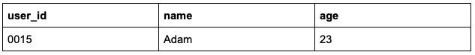
APPEND INTO users VALUES (“0015”, “Adam”, 23)
INSERT VALUES (“0015”, “Adam”, 23) INTO users
APPEND VALUES (“0015”, “Adam”, 23) INTO users
Correct answer
INSERT INTO users VALUES (“0015”, “Adam”, 23)
UPDATE users VALUES (“0015”, “Adam”, 23)
Overall explanation
INSERT INTO allows inserting new rows into a Delta table. You specify the inserted rows by value expressions or the result of a query.

Reference: https://docs.databricks.com/sql/language-manual/sql-ref-syntax-dml-insert-into.html

Study materials from our exam preparation course on Udemy:
Hands-on
Domain
ELT with Spark SQL and Python
Question 25Skipped
Given the following Structured Streaming query:

- (spark.table("orders")
- .withColumn("total_after_tax", col("total")+col("tax"))
- .writeStream
- .option("checkpointLocation", checkpointPath)
- .outputMode("append")
- .___________
- .table("new_orders") )

Fill in the blank to make the query executes multiple micro-batches to process all available data, then stops the trigger.
trigger(“micro-batches”)
trigger(once=True)
trigger(processingTime=”0 seconds")
trigger(micro-batches=True)
Correct answer
trigger(availableNow=True)
Overall explanation
In Spark Structured Streaming, we use trigger(availableNow=True) to run the stream in batch mode where it processes all available data in multiple micro-batches. The trigger will stop on its own once it finishes processing the available data.

Reference: https://docs.databricks.com/structured-streaming/triggers.html#configuring-incremental-batch-processing

Study materials from our exam preparation course on Udemy:
- Lecture
- Hands-on

Domain
Incremental Data Processing
Question 26Skipped
Which of the following techniques allows Auto Loader to track the ingestion progress and store metadata of the discovered files ?
mergeSchema
COPY INTO
Watermarking
Correct answer
Checkpointing
Z-Ordering
Overall explanation
Auto Loader keeps track of discovered files using checkpointing in the checkpoint location. Checkpointing allows Auto loader to provide exactly-once ingestion guarantees.

Reference: https://docs.databricks.com/ingestion/auto-loader/index.html#how-does-auto-loader-track-ingestion-progress

Study materials from our exam preparation course on Udemy:
- Lecture
- Hands-on

Domain
Incremental Data Processing
Question 27Skipped
A data engineer has defined the following data quality constraint in a Delta Live Tables pipeline:

CONSTRAINT valid_id EXPECT (id IS NOT NULL) _____________

Fill in the above blank so records violating this constraint cause the pipeline to fail.
ON VIOLATION FAIL
Correct answer
ON VIOLATION FAIL UPDATE
ON VIOLATION DROP ROW
ON VIOLATION FAIL PIPELINE
There is no need to add ON VIOLATION clause. By default, records violating the constraint cause the pipeline to fail.
Overall explanation
With ON VIOLATION FAIL UPDATE, records that violate the expectation will cause the pipeline to fail. When a pipeline fails because of an expectation violation, you must fix the pipeline code to handle the invalid data correctly before re-running the pipeline.

Reference:
https://learn.microsoft.com/en-us/azure/databricks/workflows/delta-live-tables/delta-live-tables-expectations#--fail-on-invalid-records

Study materials from our exam preparation course on Udemy:
- Hands-on

Domain
Incremental Data Processing
Question 28Skipped
In multi-hop architecture, which of the following statements best describes the Silver layer tables?
They maintain data that powers analytics, machine learning, and production applications
They maintain raw data ingested from various sources
The table structure in this layer resembles that of the source system table structure with any additional metadata columns like the load time, and input file name.
They provide business-level aggregated version of data
Correct answer
They provide a more refined view of raw data, where it’s filtered, cleaned, and enriched.
Overall explanation
Silver tables provide a more refined view of the raw data. For example, data can be cleaned and filtered at this level. And we can also join fields from various bronze tables to enrich our silver records

Reference:
https://www.databricks.com/glossary/medallion-architecture

Study materials from our exam preparation course on Udemy:
- Lecture
- Hands-on

Domain
Incremental Data Processing
Question 29Skipped
The data engineer team has a DLT pipeline that updates all the tables at defined intervals until manually stopped. The compute resources of the pipeline continue running to allow for quick testing.

Which of the following best describes the execution modes of this DLT pipeline ?
The DLT pipeline executes in Continuous Pipeline mode under Production mode.
Correct answer
The DLT pipeline executes in Continuous Pipeline mode under Development mode.
The DLT pipeline executes in Triggered Pipeline mode under Production mode.
The DLT pipeline executes in Triggered Pipeline mode under Development mode.
More information is needed to determine the correct response
Overall explanation
Continuous pipelines update tables continuously as input data changes. Once an update is started, it continues to run until the pipeline is shut down.

In Development mode, the Delta Live Tables system ease the development process by
- Reusing a cluster to avoid the overhead of restarts. The cluster runs for two hours when development mode is enabled.
- Disabling pipeline retries so you can immediately detect and fix errors.

Reference:
https://docs.databricks.com/workflows/delta-live-tables/delta-live-tables-concepts.html

Study materials from our exam preparation course on Udemy:
- Hands-on

Domain
Incremental Data Processing
Question 30Skipped
Given the following Structured Streaming query:

- (spark.readStream
- .table("cleanedOrders")
- .groupBy("productCategory")
- .agg(sum("totalWithTax"))
- .writeStream
- .option("checkpointLocation", checkpointPath)
- .outputMode("complete")
- .table("aggregatedOrders")
- )

Which of the following best describe the purpose of this query in a multi-hop architecture?
The query is performing raw data ingestion into a Bronze table
The query is performing a hop from a Bronze table to a Silver table
Correct answer
The query is performing a hop from Silver layer to a Gold table
The query is performing data transfer from a Gold table into a production application
This query is performing data quality controls prior to Silver layer
Overall explanation
The above Structured Streaming query creates business-level aggregates from clean orders data in the silver table cleanedOrders, and loads them in the gold table aggregatedOrders.

Reference:
https://www.databricks.com/glossary/medallion-architecture

Study materials from our exam preparation course on Udemy:
- Lecture
- Hands-on

Domain
Incremental Data Processing
Question 31Skipped
Given the following Structured Streaming query:

- (spark.readStream
- .table("orders")
- .writeStream
- .option("checkpointLocation", checkpointPath)
- .table("Output_Table")
- )

Which of the following is the trigger Interval for this query ?
Correct answer
Every half second
Every half min
Every half hour
The query will run in batch mode to process all available data at once, then the trigger stops.
More information is needed to determine the correct response
Overall explanation
By default, if you don’t provide any trigger interval, the data will be processed every half second. This is equivalent to trigger(processingTime=”500ms")

Reference: https://docs.databricks.com/structured-streaming/triggers.html#what-is-the-default-trigger-interval

Study materials from our exam preparation course on Udemy:
- Lecture
- Hands-on

Domain
Incremental Data Processing
Question 32Skipped
A data engineer has the following query in a Delta Live Tables pipeline

- CREATE STREAMING TABLE sales_silver
- AS
- SELECT store_id, total + tax AS total_after_tax
- FROM LIVE.sales_bronze

The pipeline is failing to start due to an error in this query.

Which of the following changes should be made to this query to successfully start the DLT pipeline ?
- CREATE LIVE TABLE sales_silver
- AS
- SELECT store_id, total + tax AS total_after_tax
- FROM STREAMING(LIVE.sales_bronze)
- CREATE STREAMING TABLE sales_silver
- AS
- SELECT store_id, total + tax AS total_after_tax
- FROM LIVE(STREAM.sales_bronze)
- CREATE STREAMING TABLE sales_silver
- AS
- SELECT store_id, total + tax AS total_after_tax
- FROM STREAM(sales_bronze)
- CREATE STREAMING TABLE sales_silver
- AS
- SELECT store_id, total + tax AS total_after_tax
- FROM STREAMING(LIVE.sales_bronze)
Correct answer
- CREATE STREAMING TABLE sales_silver
- AS
- SELECT store_id, total + tax AS total_after_tax
- FROM STREAM(LIVE.sales_bronze)
Overall explanation
In DLT pipelines, You can stream data from other tables in the same pipeline by using the STREAM() function. In this case, you must define a streaming table using the CREATE STREAMING TABLE syntax*.

Remember, to query another DLT table, prepend always the LIVE. keyword to the table name.

- CREATE STREAMING TABLE table_name
- AS
- SELECT *
- FROM STREAM(LIVE.another_table)

* Note that the previously used CREATE STREAMING LIVE TABLE syntax is now deprecated; however, you may still encounter it in the current exam version.

Reference: https://docs.databricks.com/workflows/delta-live-tables/delta-live-tables-incremental-data.html#streaming-from-other-datasets-within-a-pipeline&language-sql

Study materials from our exam preparation course on Udemy:
Hands-on

Domain
Incremental Data Processing
Question 33Skipped
In multi-hop architecture, which of the following statements best describes the Gold layer tables?
They provide a more refined view of the data
They maintain raw data ingested from various sources
The table structure in this layer resembles that of the source system table structure with any additional metadata columns like the load time, and input file name.
Correct answer
They provide business-level aggregations that power analytics, machine learning, and production applications
They represent a filtered, cleaned, and enriched version of data
Overall explanation
Gold layer is the final layer in the multi-hop architecture, where tables provide business level aggregates often used for reporting and dashboarding, or even for Machine learning.

Reference:
https://www.databricks.com/glossary/medallion-architecture

Study materials from our exam preparation course on Udemy:
- Lecture
- Hands-on
Domain
Incremental Data Processing
Question 34Skipped
The data engineer team has a DLT pipeline that updates all the tables once and then stops. The compute resources of the pipeline terminate when the pipeline is stopped.

Which of the following best describes the execution modes of this DLT pipeline ?
The DLT pipeline executes in Continuous Pipeline mode under Production mode.
The DLT pipeline executes in Continuous Pipeline mode under Development mode.
Correct answer
The DLT pipeline executes in Triggered Pipeline mode under Production mode.
The DLT pipeline executes in Triggered Pipeline mode under Development mode.
More information is needed to determine the correct response
Overall explanation
Triggered pipelines update each table with whatever data is currently available and then they shut down.

In Production mode, the Delta Live Tables system:
- Terminates the cluster immediately when the pipeline is stopped.
- Restarts the cluster for recoverable errors (e.g., memory leak or stale credentials).
- Retries execution in case of specific errors (e.g., a failure to start a cluster)

Reference:
https://docs.databricks.com/workflows/delta-live-tables/delta-live-tables-concepts.html

Study materials from our exam preparation course on Udemy:
- Hands-on
Domain
Incremental Data Processing
Question 35Skipped
A data engineer needs to determine whether to use Auto Loader or COPY INTO command in order to load input data files incrementally.

In which of the following scenarios should the data engineer use Auto Loader over COPY INTO command ?
Correct answer
If they are going to ingest files in the order of millions or more over time
If they are going to ingest few number of files in the order of thousands
If they are going to load a subset of re-uploaded files
If the data schema is not going to evolve frequently
There is no difference between using Auto Loader and Copy Into command
Overall explanation
Here are a few things to consider when choosing between Auto Loader and COPY INTO command:

- If you’re going to ingest files in the order of thousands, you can use COPY INTO. If you are expecting files in the order of millions or more over time, use Auto Loader.
- If your data schema is going to evolve frequently, Auto Loader provides better primitives around schema inference and evolution.

Reference: https://docs.databricks.com/ingestion/index.html#when-to-use-copy-into-and-when-to-use-auto-loader

Study materials from our exam preparation course on Udemy:
- Lecture
- Hands-on
Domain
Incremental Data Processing
Question 36Skipped
From which of the following locations can a data engineer set a schedule to automatically refresh a Databricks SQL query ?
From the jobs Ul
From the SQL warehouses page in Databricks SQL
From the Alerts page in Databricks SQL
Correct answer
From the query's page in Databricks SQL
There is no way to automatically refresh a query in Databricks SQL. Schedules can be set only for dashboards to refresh their underlying queries.
Overall explanation
In Databricks SQL, you can set a schedule to automatically refresh a query from the query's page.

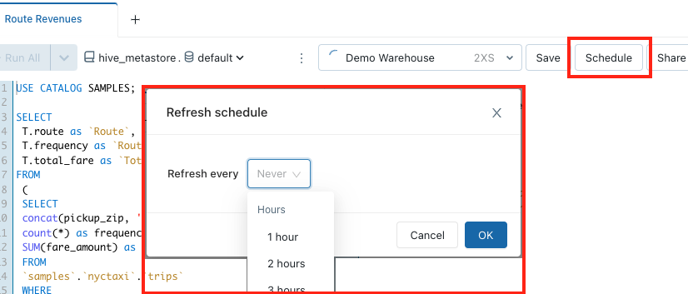

Reference: https://docs.databricks.com/sql/user/queries/schedule-query.html

Study materials from our exam preparation course on Udemy:
Hands-on

Domain
Production Pipelines
Question 37Skipped
Databricks provides a declarative ETL framework for building reliable and maintainable data processing pipelines, while maintaining table dependencies and data quality.

Which of the following technologies is being described above?
Correct answer
Delta Live Tables
Delta Lake
Databricks Jobs
Unity Catalog Linage
Databricks SQL
Overall explanation
Delta Live Tables is a framework for building reliable, maintainable, and testable data processing pipelines. You define the transformations to perform on your data, and Delta Live Tables manages task orchestration, cluster management, monitoring, data quality, and error handling.

Reference: https://docs.databricks.com/workflows/delta-live-tables/index.html

Study materials from our exam preparation course on Udemy:
Hands-on

Domain
Production Pipelines
Question 38Skipped
Which of the following services can a data engineer use for orchestration purposes in Databricks platform ?
Delta Live Tables
Cluster Pools
Correct answer
Databricks Jobs
Data Explorer
Unity Catalog Linage
Overall explanation
Databricks Jobs allow to orchestrate data processing tasks. This means the ability to run and manage multiple tasks as a directed acyclic graph (DAG) in a job.

Reference: https://docs.databricks.com/workflows/jobs/jobs.html

Study materials from our exam preparation course on Udemy:
Hands-on

Domain
Production Pipelines
Question 39Skipped
A data engineer has a Job with multiple tasks that takes more than 2 hours to complete. In the last run, the final task unexpectedly failed.

Which of the following actions can the data engineer perform to complete this Job Run while minimizing the execution time ?
They can rerun this Job Run to execute all the tasks
Correct answer
They can repair this Job Run so only the failed tasks will be re-executed
They need to delete the failed Run, and start a new Run for the Job
They can keep the failed Run, and simply start a new Run for the Job
They can run the Job in Production mode which automatically retries execution in case of errors
Overall explanation
You can repair failed multi-task jobs by running only the subset of unsuccessful tasks and any dependent tasks. Because successful tasks are not re-run, this feature reduces the time and resources required to recover from unsuccessful job runs.

Reference: https://docs.databricks.com/workflows/jobs/repair-job-failures.html

Study materials from our exam preparation course on Udemy:
Hands-on

Domain
Production Pipelines
Question 40Skipped
A data engineering team has a multi-tasks Job in production. The team members need to be notified in the case of job failure.

Which of the following approaches can be used to send emails to the team members in the case of job failure ?
They can use Job API to programmatically send emails according to each task status
Correct answer
They can configure email notifications settings in the job page
There is no way to notify users in the case of job failure
Only Job owner can be configured to be notified in the case of job failure
They can configure email notifications settings per notebook in the task page
Overall explanation
Databricks Jobs support email notifications to be notified in the case of job start, success, or failure. Simply, click Edit email notifications from the details panel in the Job page. From there, you can add one or more email addresses.

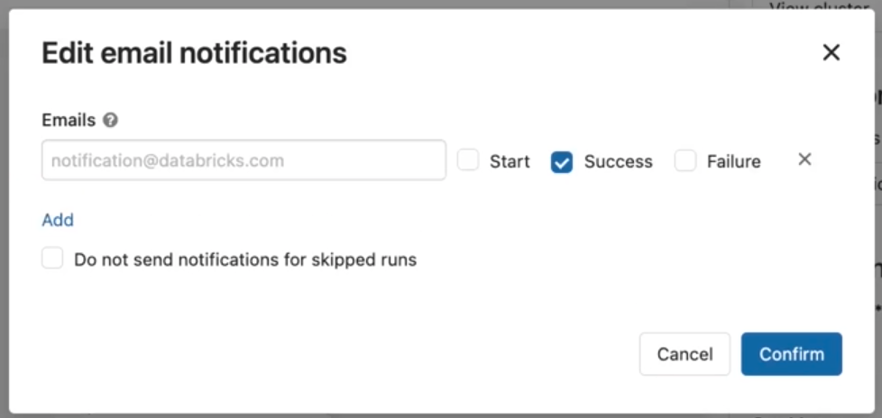

Reference: https://docs.databricks.com/workflows/jobs/jobs.html#alerts-job

Study materials from our exam preparation course on Udemy:
Hands-on

Domain
Production Pipelines
Question 41Skipped
For production jobs, which of the following cluster types is recommended to use?
All-purpose clusters
Production clusters
Correct answer
Job clusters
On-premises clusters
Serverless clusters
Overall explanation
Job Clusters are dedicated clusters for a job or task run. A job cluster auto terminates once the job is completed, which saves cost compared to all-purpose clusters.
In addition, Databricks recommends using job clusters in production so that each job runs in a fully isolated environment.

Reference: https://docs.databricks.com/workflows/jobs/jobs.html#choose-the-correct-cluster-type-for-your-job

Study materials from our exam preparation course on Udemy:
Hands-on
Domain
Production Pipelines
Question 42Skipped
In Databricks Jobs, which of the following approaches can a data engineer use to configure a linear dependency between Task A and Task B ?
Correct answer
They can select the Task A in the Depends On field of the Task B configuration
They can assign Task A an Order number of 1, and assign Task B an Order number of 2
They can visually drag and drop an arrow from Task A to Task B in the Job canvas
They can configure the dependency at the notebook level using the dbutils.jobs utility
Databricks Jobs do not support linear dependency between tasks. This can only be achieved in Delta Live Tables pipelines
Overall explanation
You can define the order of execution of tasks in a job using the Depends on dropdown menu. You can set this field to one or more tasks in the job.

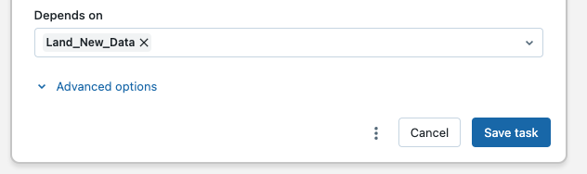

Reference: https://docs.databricks.com/workflows/jobs/jobs.html#task-dependencies

Study materials from our exam preparation course on Udemy:
Hands-on

Domain
Production Pipelines
Question 43Skipped
Which part of the Databricks Platform can a data engineer use to revoke permissions from users on tables ?
Correct answer
Data Explorer
Cluster event log
Workspace Admin Console
DBFS
There is no way to revoke permissions in Databricks platform. The data engineer needs to clone the table with the updated permissions
Overall explanation
Data Explorer in Databricks SQL allows you to manage data object permissions. This includes revoking privileges on tables and databases from users or groups of users.

Reference: https://docs.databricks.com/security/access-control/data-acl.html#data-explorer

Study materials from our exam preparation course on Udemy:
- Hands-on
Domain
Data Governance
Question 44Skipped
A data engineer uses the following SQL query:

GRANT USAGE ON DATABASE sales_db TO finance_team

Which of the following is the benefit of the USAGE privilege ?
Gives read access on the database
Gives full permissions on the entire database
Gives the ability to view database objects and their metadata
Correct answer
No effect! but it's required to perform any action on the database
USAGE privilege is not part of the Databricks governance model
Overall explanation
The USAGE does not give any abilities, but it's an additional requirement to perform any action on a schema (database) object.

Reference: https://docs.databricks.com/security/access-control/table-acls/object-privileges.html#privileges

Study materials from our exam preparation course on Udemy:
- Lecture
- Hands-on

Domain
Data Governance
Question 45Skipped
In which of the following locations can a data engineer change the owner of a table?
In DBFS, from the properties tab of the table’s data files
In Data Explorer, under the Permissions tab of the table's page
Correct answer
In Data Explorer, from the Owner field in the table's page
In Data Explorer, under the Permissions tab of the database's page, since owners are set at database-level
In Data Explorer, from the Owner field in the database's page, since owners are set at database-level
Overall explanation
From Data Explorer in Databricks SQL, you can navigate to the table's page to review and change the owner of the table. Simply, click on the Owner field, then Edit owner to set the new owner.

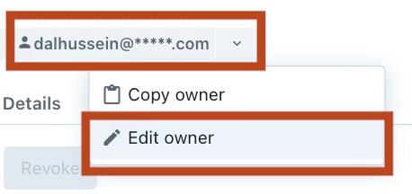

Reference: https://docs.databricks.com/security/access-control/data-acl.html#manage-data-object-ownership

Study materials from our exam preparation course on Udemy:
- Hands-on
Domain
Data Governance

